**Depression and suicide psychology**

Maïckery Bozor

July 23, 2020

# Introduction

## Background

Suicide is a phenomenon that affects all regions of the world, in fact, 75% of suicides occurred in low-and middle- income countries in 2012. Suicide accounted for 1.4% of death worldwide. Mental disorders (depression, personality disorders, alcohol dependence or schizophrenia…), certain physical illnesses such as neurological disorders, cancer and HIV infections are risk factor for suicide.

More than 800,000 people per year die by committing suicide. Each year, millions of people are therefore faced with cruel losses due to suicide. These deaths can occur at any age in life. In the optic of help to decrease this quantity of suicides, Dr Christine Dupre would like to open a new psychologist’s office. She has the idea of settling somewhere where statistically there is the highest level of suicides in the world.

## Problem

Data will use to determinate the country with the highest level of suicides, features will be determinate. In this project we will try to find an optimal location for the clinic of Dr Christine Dupre, we will try to detect locations that are away from traffic noise, like she asked it.

## Interest

Certainly all psychologists wanting to determine a target clientele, or wishing to move where they will have a better market share. And OMS whom want to find more data about suicides for have better prevention ideas against suicide.

# Data acquisition and cleaning

## Data sources

Population died by suicide, their age, their gender, the country where they was can be found in this Kaggle dataset : “<https://www.kaggle.com/russellyates88/suicide-rates-overview-1985-to-2016>”. I do additional research on Google to complete the best location idea with foursquare.

## Data cleaning

Worldwide suicides from 1985 to 2012 have all information that I want, no web scrapping was needed. I d ecide to analyze values from all year and based my conclusion on the evolution of these values to 2012, for example Russia was the country with the highest rate of suicide but in 2000-2012 United Stated replace it. I separate the feature of this analyze by making a groupby, I zoom every values of my dataset to establish the relation between every one with the total suicide. I do different graph to show the difference level of suicide for each of them.

# Exploratory Data

## Relation between suicide and country

The dataframe have 101 country established over a period of 20 years or so, 1985-2012. The analyzis the data show the ten countries with the highest suicide rate in the world.

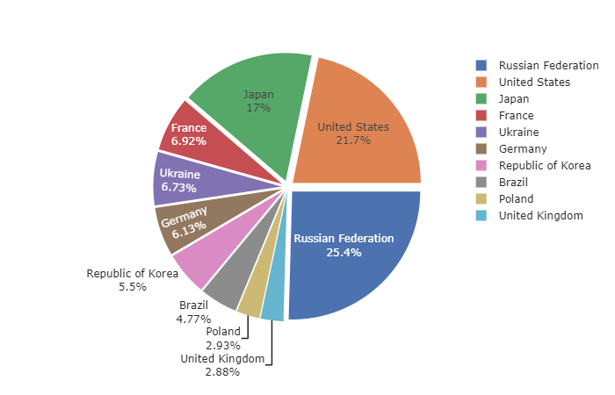

**Russian federation**, currently Russia, is the country with the highest suicide rate in the world like we can see it. But   
in the following years the United States will win this title.

Like show here

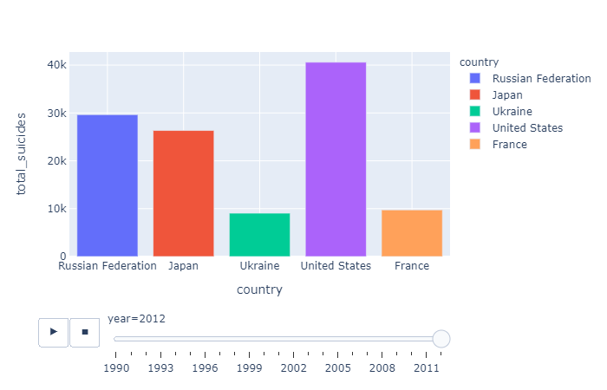

.

## Relation between suicide and sexe

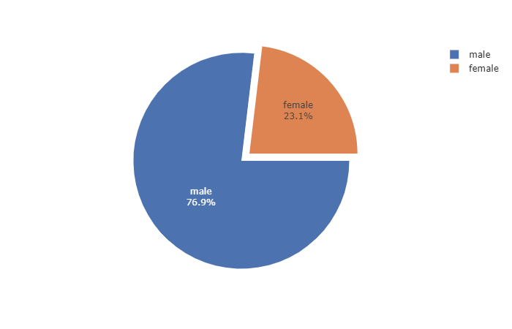

On the 6,748,420 suicides the majority is **male**, i.e. 5,188,910 (76.9%)

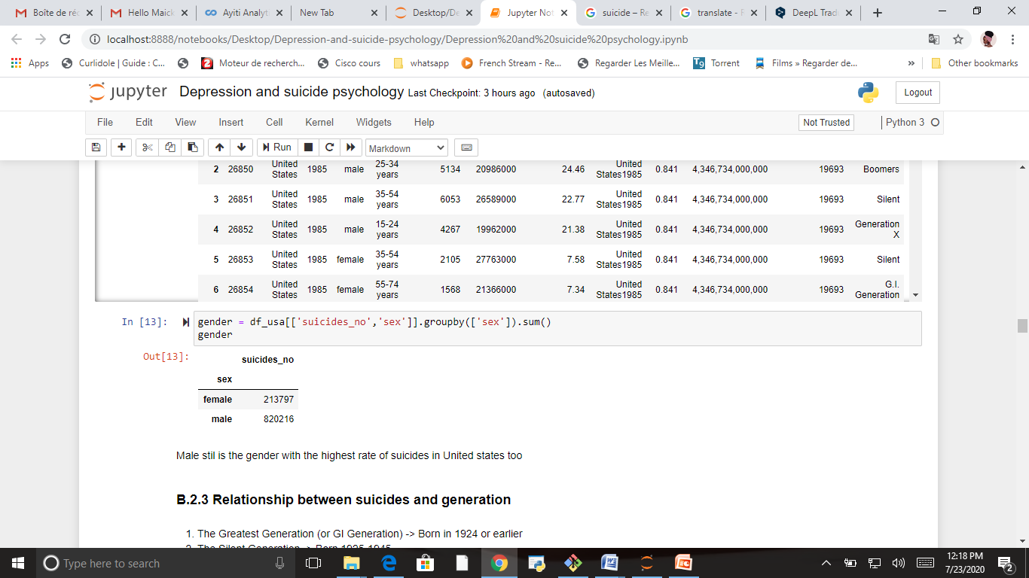For United State the quantity is different but the conclusion is the same. Male have the highest rate of suicide (as shown in this table)

## Relation between suicide and generation

The pie chart shows the rate of suicide by generation for all country in the database, and the table the rate of suicide by generation only for United-State. As show, Baby Boomers are the generation with the highest level of rate in the both case.

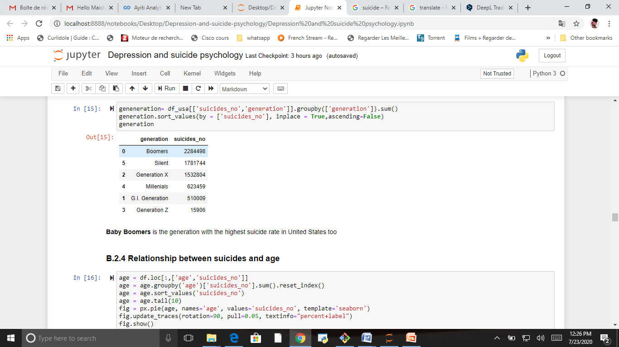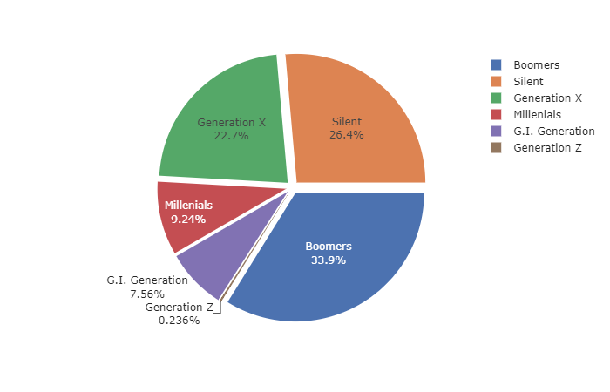

## Relation between suicide and age

People aged 35 to 54 are more likely to commit suicide, as shown in the pie chart. The conclusion remains the same when we analyze the data for the United States (the table)

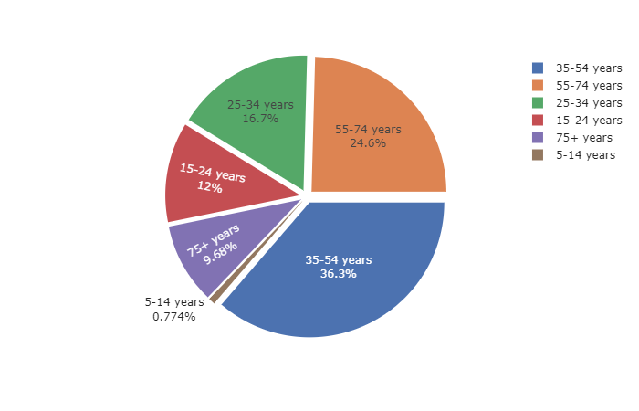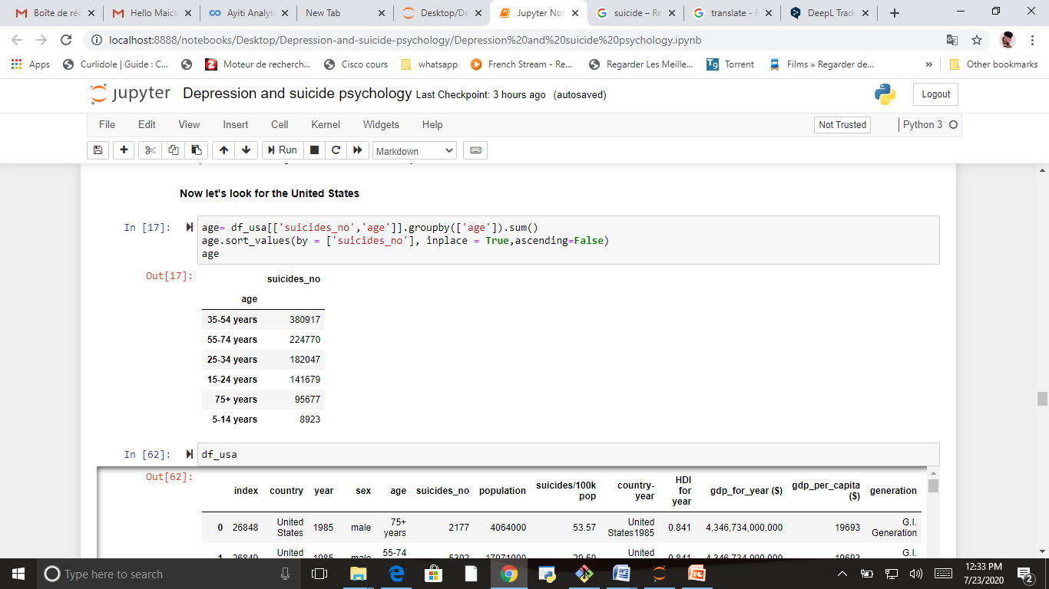

# Discussion & Conclusion

The exploratory of the suicide data from 1985 to 2015 let's us to conclude that: *The highest suicide rate is recorded in the United States, specifically among men aged 35 to 54.*

Based on the exploratory of the worldwide suicide data, factors that will influence our decision are:

* Country with the highest suicides rate ( with highest male aged between 35-54)
* as few clinics near as possible
* away from traffic noise

According to a research **California** have the highest population over all the states of USA, and Los Angeles have the highest level of population in California. Los Angeles is the second largest city in the United States in terms of population after New York. Located in the southern state of California on the Pacific coast, the city is the seat of Los Angeles County.

Los Angeles is the best destination for Dr Dupre to open his new clinic